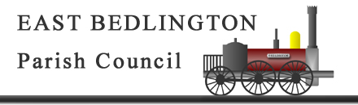

To: ALL MEMBERS OF THE COUNCIL

You are hereby requested to attend the Annual Meeting of EAST BEDLINGTON PARISH COUNCIL to be held at East Bedlington Community Centre, on Tuesday 5th May 2015 at 5:30 pm.

The Agenda for the meeting is set out below.

Ron Thornton
Parish Clerk 29 April 2015
___________________________________________________________________________________

A G E N D A

- ELECTION OF CHAIR FOR 2015/16.

- TO RECEIVE THE CHAIR’S DECLARATION OF ACCEPTANCE.

- ELECTION OF VICE CHAIR.

- APOLOGIES FOR ABSENCE.

- MINUTES.
To approve the minutes of the previous Annual Meeting held on Tuesday 6 May 2014.

- DISCLOSURES OF INTERESTS & REQUESTS FOR DISPENSATION

- RESOLUTIONS:

- To approve the schedule of Parish Council Meetings.
- To approve nominations on to outside bodies;

- Northumberland Association of Local Councils (1) member
- East Bedlington Community Centre Management Board (3) Members / Officers
- Friends of Gallagher Park (1) Member
- Bedlington Forum (2) Members

EAST BEDLINGTON PARISH COUNCILLORS: Joe Dobie, Eddiie Dickson, Andrea Innes, David Graham, Paul Hedley, Nicola Hogarth, Terry Johnstone, Andy Watson, Colin Parker, Allan Stewart and Alex Wallace.

